Health Benefits Associated with Date Palms
HN&F 401- Senior Semenar in Nutrition.
Maram Murad

Table of Contents
Introduction: 2
Body: 3-11
Study (A) Glycemic Indexes of Five Varieties of Dates in Healthy and Diabetic Subjects.
Study (B) Metabolic Consequences of Date Snack Before a Meal.
Study (C) Glycemic Index of Ripped Date, Alone and With Yoghurt.
Study (D) A comparison of acute glycemic and insulin response to dates and oral dextrose in diabetic and non-diabetic subjects
Study (E) Glycémie index of 3 varieties of dates

Study (F) Susceptibility of imipenem-resistant Pseudomonas aeruginosa to flavonoid glycosides of date palm
Study (G) Antimicrobial activity of date palm pits extracts and its role in reducing the side effect of methyl prednisolone on some neurotransmitter content in the brain, hormone testrone in adulthood.

Study (H) Sperm quality improvement after date seed oil in vitro supplementation in spontaneous and induced oxidative stress.
Study (I) In vivo comparative studies on antigenotoxicity of date palm (phoenix dactylifera L.) pits extract against DNA damage induced by N-nitroso-N-methylurea in mice.
Study (J) Protective effect of date palm fruit extract (phoenix dactylifera L.) on dimethoate induced-oxidative stress in rat liver.
Conclusion: 11
Future Research: 12

References: 13-14

Introduction:

Dates are small, sweet fruits that grow on date palm trees. They might be considered as an almost ideal food, providing a wide range of essential nutrients and potential health benefit.
The important quality criteria for consumers are the appearance including color, size, and shape. Physical condition and absence of defects, mouth feel or texture, flavor, ripeness, and nutritional value are also considered when consuming dates. The date fruit (P. dactyliferia L., Palmae) of the date palm contain a high percentage of carbohydrate (total sugars, 44-88%), fat (0.2-0.5%), 15 salts and minerals, protein (2.3-5.6%), vitamins and a high percentage of dietary fiber (6.4-11.5%). Yet, the flesh of dates contains 0.2- 0.5% oil, whereas the seed contains 7.7-9.7% oil, which is 5.6-14.2% of the date. The fatty acids appear in both flesh and seed as a range of saturated and unsaturated acids, the seeds containing 14 types of fatty acids, but only eight of these fatty acids occur in very low concentration in the flesh. Unsaturated fatty acids include palmitoleic oleic, linoleic and linolenic acids. The oleic acid content of the seeds varies from 41.1 to 58.8%, which suggests that the seeds of date could be used as a source of oleic acid. There are at least 15 minerals in dates. The percentage of each mineral in dried dates varies from 0.1 to 916-mg/100 g depending on the type of mineral. Likewise, potassium can be found at a concentration as high as 0.9% in the flesh while it is as high as 0.5% in some seeds. Other minerals and salts that are found in various proportions include boron, calcium, cobalt, copper, fluorine, iron, magnesium, manganese, potassium, phosphorous, sodium and zinc. Additionally, the seeds contain aluminum, cadmium, chloride, lead and sulfur in various proportions. Moreover, the protein in dates contains 23 types of amino acids, some of which are not present in the most popular fruits that people consumes. Also, dates contain at least six vitamins including a small amount of vitamin C, and vitamins B1 thiamine, B2 riboflavin, nicotinic acid (niacin), and vitamin A. And the dietary fiber has been shown to be as high as 6.4-11.5% depending on variety and degree of ripeness.Furthermore, date palms are an important source of nutrition, especially in the arid regions where due to the extreme conditions, very few plants can actually grow. Also, dates are considered to be a good source of low cost food and are an essential part in some cultures diets, for instance, Arabian diet. In this research, i am addressing particularly how the date’s palms low glycemic indexes, antimicrobial flavonoids, and strong antioxidants properties possess diverse health benefits.

Body:
The prevalence of type-2 Diabetes mellitus is rising all around the world. The consumption of low glycemic index diet has been shown to have benefits for glycemic and lipid control. To test to glycemic index in dates, study (A) was designed to test the glycemic indexes (GIs) of five varieties of dates in healthy and diabetic subjects. As shown in (figure 1), the study was mainly designed to determine the glycemic indexes and their effects on postprandial glucose excursions in both healthy individuals, and individuals with type 2 Diabetes mellitus. The study subjects were thirteen healthy volunteers with a mean age of 40.2 ± 6.7 years and ten participants with type 2 diabetes mellitus (controlled on lifestyle measures and/or metformin). Each subject was tested on eight separate days with 50 g of glucose (on 3 occasions) and 50 g equivalent of available carbohydrates from the five varieties of date fara’d, lulu, bo ma’an, dabbas and khalas. Capillary glucose was measured in both the healthy subjects and for the diabetics at the same time. Statistical analyses were performed using the Mann-Whitney test and repeated measures analysis of variance.
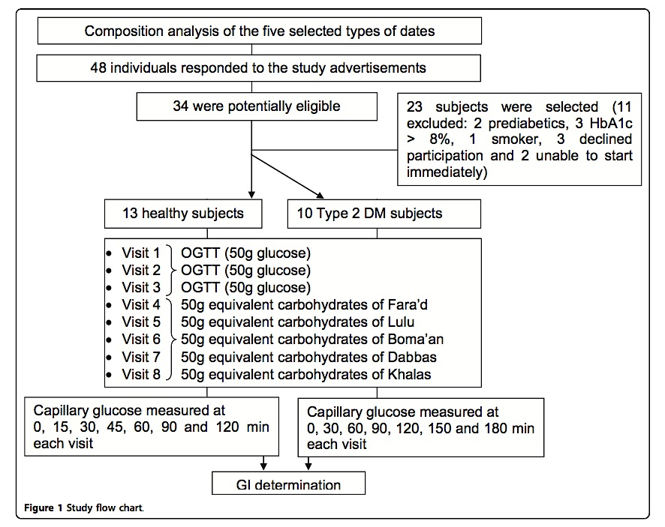
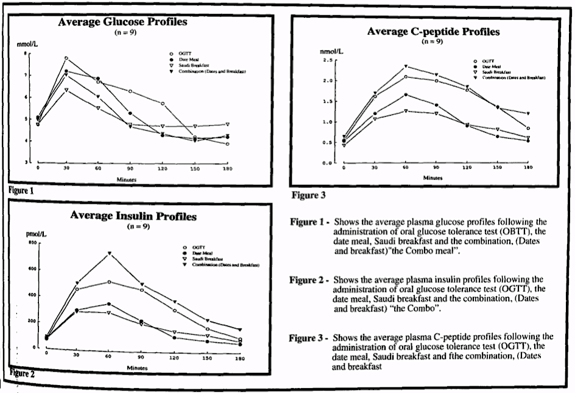
As a result, (Table 4) shows the mean glycemic indexes ± SEM of the dates for the healthy individuals, and corresponding values for those with type 2 Diabetes. The comparison showed that there were no statistically significant differences in the GIs between the control and the diabetic groups for the five types of dates, nor were there statistically significant differences among the dates’ glycemic indexes. As a conclusion, the results show low glycemic indexes for the five types of dates included in the study and that their consumption by diabetic individuals does not result in significant postprandial glucose excursions. These findings point to the potential benefits of dates for diabetic subjects when used in a healthy balanced diet. Yet, study (B) tested the metabolic consequences of eating dates before a meal. This study focused on the metabolic impact of the ingestion of four groups: a group who had dates right before a breakfast meal “combo meal”, a group who had only dates (which contain 74.5g CHO), a group who ate breakfast, and a group who had 75g glucose solution, oral glucose tolerance test (OGTT). As (Figure 2) shows, in the combo meal group, glucose plasma was significantly lower than those who got the glucose solution. However, glucose plasma didn’t show a difference when compared to the group that ate date only or breakfast only. Yet, insulin in the combo meal was similar to those who had the glucose solution. As a conclusion, the combo meal does not appear to influence the glucose tolerance in normal subjects. Yet, a comparison of acute glycemic and insulin response to dates and oral dextrose in diabetic and non-diabetic subjects has been tested. Study (C) aimed to answer the following questions: What is the magnitude of the change in blood glucose and insulin levels when diabetic patients and healthy controls eat dates? And how do these changes compare with the response to an isocaloric amount of pure dextrose in the same subjects? The results supported that blood glucose was significantly higher in dextrose than dates. Therefore, dates stimulate less insulin secretion than dextrose in healthy subjects. This finding shares the same results of studies (A) and (B).
Figure 2
Moreover, study (D) was prepared to determine the glycemic index of ripped dates, alone and in mixed meals (with plain full-milk yoghurt). Subjects were healthy male and female volunteers aged in the wide ranged of 32-67 years. Glycemic indexes were compared using paired t-tests. As the result shown in (Table 2), when dates are eaten alone or in mixed meals with plain yoghurt, they tend to have lower glycemic indexes. As a conclusion, the consumption of dates may benefit in glycemic and lipid control of diabetic patients. And the consumption of dates in mixed meals with yoghurt appears to have, at most, a minimal effect on the glycemic index. And finally, study (E) also tested in detail the glycemic indexes of three varieties of dates. The three varieties of dates tested in this study were khalas, barhi, and bo ma’an. The available carbohydrate content of the dates was determined by standard labs methods. Normal volunteer subjects were fed each type of dates. And glycemic indexes were calculated by standard methods. As a conclusion, dates were classified as low glycemic index food items. The consumption of three varieties of dates tested in this study may benefit in glycemic and lipid control of diabetic patents. Yet, (table 6) outlines the GI results for the three dates varieties. And using the paired t-tests, there were a slight differences in the GIs between bo ma’am and the other two varieties. However, according to the results, dates can be classified as low GI food item and comparable with or lower than many other fruits. And the date’s low glycemic index is suggested to be due to its high fructose content.

Table 2
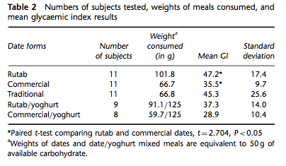
Table 4
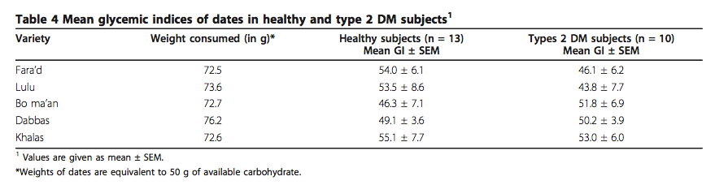
Table 6
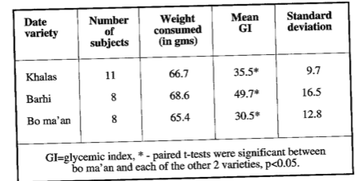
Furthermore, flavonoids are ubiquitous in photosynthesising cells and are commonly found in fruit such as vegetables, nuts, seeds, stems, flowers, tea, and honey. For centuries, preparations containing these compounds as the principal physiologically active constituents have been used to treat human diseases. Many groups have isolated and identified the structures of flavonoids possessing antifungal, antiviral and antibacterial activity. A study was made to determine the susceptibility of Imipenem-resistant Pseudomonas aeruginosa to flavonoid glycosides of date palms. Moreover, in study (F) all experiments were performed in triplicate with three discs tested with date extract suspension and three discs tested with control suspension for each isolate. Flavonoid content in the methanolic extract of plant was determined using the aluminum chloride calorimetric method. As a result, it was found that dates contain a wide array of flavones, but little is known about the antimicrobial of flavonoid glycosides compounds in dates. The study evaluated the antimicrobial of flavonoid glycosides extracted from the date fruits at full ripe stage against Imipenem-resistant P. aeruginosa (IRP). A chloroform fraction prepared from the date showed potent inhibitory activity against IRP. The active compounds were elucidated to be quercetin, luteolin, and apigenin based on their spectral analysis. Flavonoid glycosides showed significant antibacterial activities against IRP. These compounds represent novel leads. From the SEM results (Figure 3), it was clearly indicated that the cell morphology of P. aeruginosa when treated with flavonoid glycosides, started to deform at 30 min onward and at 60 min, most cells were completely deformed whose results was correlated to their strong antibacterial activity. Therefore, it can be suggested that flavonoid glycosides compounds may interact with or damage the cell wall of P . aeruginosa as seen by the formation of pores on the cell wall of P . aeruginosa (Figure 3). These results indicate the exploitation of flavonoid glycosides from date palms to be effective inhibitors of IRP. (Figure 4) shows the effect of date extract (5%) on viability of P.aeruginosa. Values are the average of three individual replicates. Differences between samples were determined by the student’s t-test and were considered to be significant when p < or = 0.05. Furthermore, study (G), focused on antimicrobial activity of date palm pits extracts and its role in reducing the side effect of methyl prednisolone on some neurotransmitter content in the brain, hormone testosterone in adulthood. The experiment started with the reparation of date palm pits. The dried pits were ground into a fine powder and immersed in cold distilled water for 48hr. The water extract was prepared freshly and given to the animals. And to test the antibacterial activities, the agar disc diffusion method was employed. Also, some known antibiotics were evaluated for their antibacterial activities and their results compared with date pits extract. Yet, the animals were divided into four groups of equal number, three experimental and control groups. The control group only received an equal volume of distilled water. The second group was orally and daily-administered methylprednisolone at a dose of 20 mg/kg and the third group was orally and daily administered pits of date palm. Later, the third group was orally and daily-administered 4 ml of pits of date extract (20 mg/kg) for 15 consecutive days and treated with methyl prednisolone (20mg/kg) with pits of data extract. At the end of the experimental periods (2 weeks), rats were scarified under diethyl ether anesthesia at fasting state. As a conclusion, the appropriate recommendations in this study are to use nuclei date’s antimicrobial properties on Klebsiella pneumonia and Escherichia coli than the activity of standard antibiotics. This result concluded that using intended date palm pits as a preventive measure to reduce the side effects resulting from the use of the drug Methyl Prednisolone on some neurotransmitter content in the brain, and hormone testosterone in male albino rats.

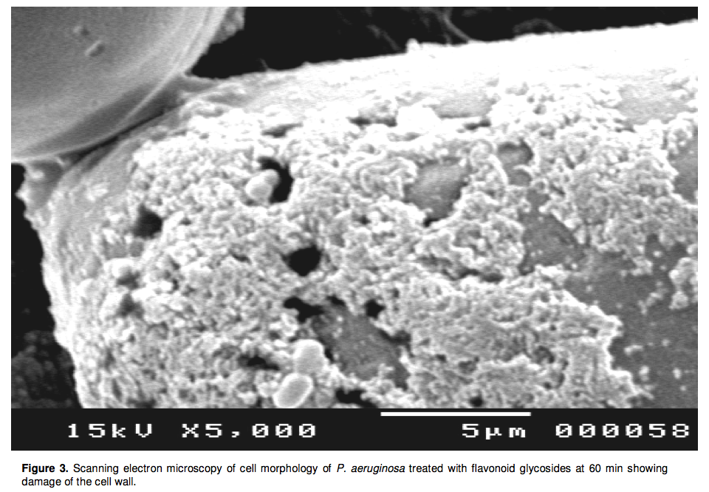
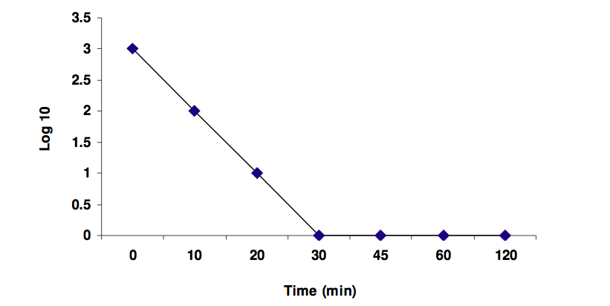
Figure 4. the effect of date extract (5%) on viability of P. aeruginosa
Further studies were testing date antioxidants properties, study (H) tested the date palm antioxidant effects on human sperm motility, sperm viability, and reacted acrosome and lipid peroxidation assessed in vitro after hydrogen peroxide (H2O2) mediated oxidative damage in spermatozoa. It is round that, vitro supplementation with date seed oil (DSO) can protect spermatozoa against hydrogen peroxide (H2O2)- mediated damage, and can improve sperm function, possibly owing to antioxidant properties. The study tested the anti- oxidant effects of DSO on human sperms. Sixteen patients (mean age: 35 years; range: 25–45 years) referred after 12–24 months of sexual intercourse without conception were selected. Moreover, results showed that incubation with H2O2 alone led to a significant increase in lipid peroxidation (57.83%, P < 0.05) associated with a significant decrease in sperm motility, sperm viability (after 30 min and 24 h) and percentage of reacted acrosome (P < 0.05). However, DSO improved sperm motility after 24 h of incubation (P < 0.05) and protected spermatozoa against the deleterious effects of H2O2 on motility, viability, acrosome reaction and lipid peroxidation. As a conclusion, this study proved that supplementation with DSO may have a function in antioxidant protection against male infertility. Moreover, study (I) studied an aqueous extract of the date palm pits, and its antigen toxic activity. It was evaluated against N‑Nitroso‑N‑methylurea (NMU) induced mutagenic effect in mice. Date pits extract (DPE) was given orally to for five days in a week up to four consecutive weeks. NMU was used as mutagen and was given as an injection at single dose. The results have shown that pre‑and post‑treatment regimens of DPE significantly restored the DNA damage induced by NMU. These findings suggested that DPE produced their inhibitory activity either by desmutagenic or bioantimutagenic manner in pre‑and post‑treatment regimens respectively. Yet, it was suggested that the observed antimutagenic activity might be attributed to the presence of mineral and various photochemical of the date palm diverse chemical structure. Furthermore, study (J) tested the protective effect of date palm fruit extract on dimethoate induced-oxidative stress in rat liver. Nowadays, people’s exposure to chemical compounds such as organophosphorus insecticides is continuously on the rise more and more. Theses compounds have prompted an excessive production of free radicals, which are responsible for several cell alterations in the body. Recent experiments have proved the necessary role of nutritional antioxidants to prevent the damage caused by toxic compounds. In this study, the role of date palm fruit extract in protection against oxidative damage and hepatotoxicity was tested. And as a result, it was indicated that date palm fruit might be useful for the prevention of oxidative stress induced hepatotoxicity in rats.

Conclusion:
Dates are cultivated for their edible sweet fruit; they are consumed worldwide and are a dietary fundamental for many regions, as they provide the body with several essential nutrients. Yet, scientific studies have proven some health benefits with date palm associated with health. For instance: dates palm’s low glycemic indexes, antimicrobial flavonoids, and antioxidants properties. In studies (A), (B), (C), and (E): the results indicated that blood glucose was significantly higher in sugar solutions (ex: dextrose) than dates. Therefore, it is found that dates stimulate less insulin secretion than sugar in healthy subjects. And study (D) adds on, that the consumption of dates in mixed meals with yoghurt appears to have, at most, a minimal effect on the glycemic index. Moreover, study (F) and (G) emphasized on the antimicrobial properties of date palm. Study (F) indicated the possibility of exploitation of flavonoid glycosides originated from date palm to be effective inhibitors of Imipenem-resistant P. aeruginosa (IRP). And study (G) focused on antimicrobial activity of date palm pits extracts and its role in reducing the side effect of methyl prednisolone on some neurotransmitter contents. And it indicated that using intended date palm pits as a preventive measure to reduce the side effects resulting from the use of some drugs (ex: Methyl Prednisolone) on some neurotransmitter content in the brain, and hormone testosterone in male albino rats. Furthermore, studies (H) and (I) tested the date palm antioxidant properties. Study (H) concludes that, date seed oil may have a function in antioxidant protection against male infertility. And study (I) concludes that date palm extract is useful in prevention of oxidative stress induced hepatotoxicity.

Future Research:
Since results show that the consumption dates did not score in significantly high blood glucose levels, further studies can go from here, allowing patients to consume dates in similar quantities to those used in this study, without the risk of inducing undesirable postprandial excursions in blood glucose. Moreover, further studies are needed to examine the GIs of dates at different stages of maturation to measure the glycemic and metabolic responses. Yet, it is important to test the consumption of dates in individuals with type 2 Diabetics on different medication treatments, and in patients with type 1 Diabetes as well. Yet, future prospective studies could be made to evaluate the effects of long-term consumption of dates on prevention of diabetes, and on the control of high blood glucose (hyperglycemia). Moreover, more studies need to be done to test date palm’s anti microbial effect. For intense, more studies on anti-IRP agents would be beneficial. Finally, further studies should be done on humans to test the date palm’s antioxidant property in curing male infertility by improving the quality of sperms

References:

1,2,3 Al-shahib W, Marshall RJ. The fruit of the date palm: Its possible use as the best food for the future? International Journal of Food Sciences & Nutrition. 2003; 54 (4): 247. http://search.ebscohost.com
4,5 Alkaabi et al.: Glycemic indices of five varieties of dates in healthy and diabetic subjects. Nutrition Journal 2011 10:59.
6 Ahmed, M. Metabolic consequences of date snack before a meal: A tradition Arab practice. Saudi medical journal. Volume 19. Issue:3.1998. Pg:313-318
7 Famuyiwa. A comparison of acute glycemic and insulin response to dates and oral dextrose in diabetic and non-diabetic subjects. Saudi medical journal. Volume 13. Issue:5. 1992. Pg:397-402
8 Miller C, Dunn E, Hashim I. The glycemic index of dates and date/yoghurt mixed meals. are dates ‘the candy that grows on trees’? Eur J Clin Nutr. 2003;57(3):427-430.
9 Ifr&g Z. Glycémie index of 3 varieties of dates. Saudi Med J. 2002;23(5):536-538.
10,11 Samy Selim, Sahar El Alfy, Meshref Al-Ruwaili, Amin Abdo, and Soad Al Jaouni. Susceptibility of imipenem-resistant Pseudomonas aeruginosa to flavonoid glycosides of date palm (Phoenix dactylifera L.). African Journal of Biotechnology Vol. 11(2), pp. 416-422, 5 January, 2012
12 Saddiq, A.A. and Bawazir, A.E. 2010. Antimicrobial activity of date palm pits extracts and its role in reducing the side effect of methyl prednisolone on some neurotransmitter content in the brain, hormone testrone in adulthood.. Acta Hort. (ISHS) 882:665-690.www.actahort.org/books/882/882_74.htm
13 Fatma BA, Nozha CF, Ines D, Hamadi A, Basma H, Leila AK. Sperm quality improvement after date seed oil in vitro supplementation in spontaneous and induced oxidative stress. Asian J Androl. 2009;11(3):393-398.
14 Diab KAS, Aboul-Ela E. In vivo comparative studies on antigenotoxicity of date palm (phoenix dactylifera L.) pits extract against DNA damage induced by N-nitroso-N-methylurea in mice. Toxicol Int. 2012;19(3):279-286. http://search.ebscohost.com.www.libproxy.wvu.edu.: 10.4103/0971-6580.103669.
15 Saafi EB, Louedi M, Elfeki A, et al. Protective effect of date palm fruit extract (phoenix dactylifera L.) on dimethoate induced-oxidative stress in rat liver. Experimental and Toxicologic Pathology. 2011;63(5):433-441. doi: 10.1016/j.etp.2010.03.002.

